**AIR QUALITY MONITORING**

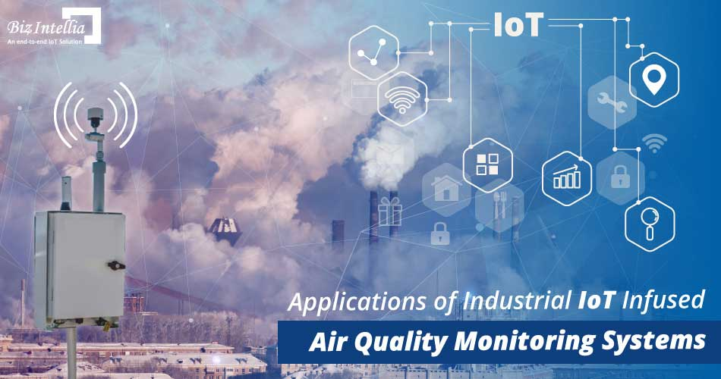 Phase 2 submission document

Team members

SOWMIYA M – 732721121049

PAVITHRA C T – 732721121038

SWETHA G K – 732721121054

KANISHKA S – 732721121021

NISHANTHINI T – 732721121034

**PROBLEM STATEMENT**:

Air quality is a critical environmental concern affecting the health and well-being of communities worldwide. Monitoring and maintaining high air quality standards are essential to ensure the safety and health of the population. Air quality management within the chemical industry is a critical concern due to the potential release of hazardous air pollutants that can harm both human health and the environment. The problem lies in the need for effective and comprehensive air quality monitoring and control systems within chemical plants to ensure compliance with environmental regulations, safeguard the well-being of employees, and prevent the release of toxic emissions.

**INNOVATION:**

Innovations in chemical industry air monitoring are essential to enhance safety, compliance, and sustainability. To reduce the air leakage at chemical industry by our project ehich is been done by the usage of sensors and methodology**.**  Internet of Things low-cost air quality monitoring system. The system utilizes air quality and carbon monoxide sensors for monitoring gaseous pollutants. Moreover, the system utilizes an Arduino Nano development board equipped with a WiFi module to effectively send readings to a ThingSpeak online channel platform for instantaneous and real-time display of air quality.

**DESIGN COMPONENTS:**

* Arduino uno
* Microcontroller ATMega 328p
* Waspmote sensor
* ESP8266 Wi fi module
* MQ135 sensor
* MQ7 sensor
* Buzzer
* LCD screen

**PIN CONNECTION:**

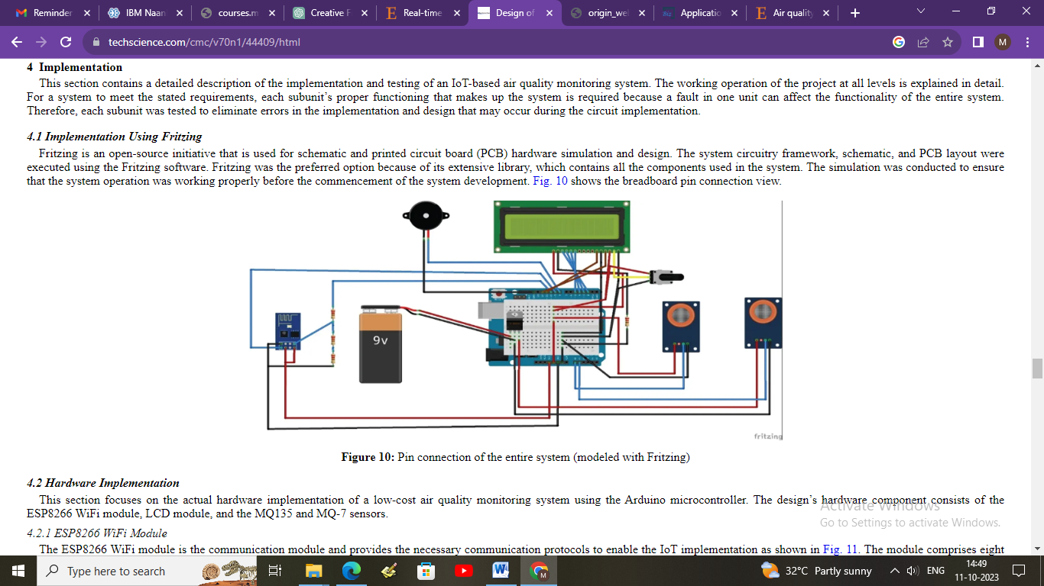

The first unit is a power supply unit, which consists of a DC jack and a regulator. The second unit is the sensing unit, which consists of an air quality sensor and a carbon monoxide sensor. Then, the third unit is the control unit, which consists of the Arduino Uno atmega microcontroller. The fourth unit is the communication unit, which consists of a WiFi module used to transfer the air quality status from the control unit to the IoT platform. Finally, the fifth unit is the output unit, which consists of an LCD, a buzzer.

**BLOCK DIAGRAM**:

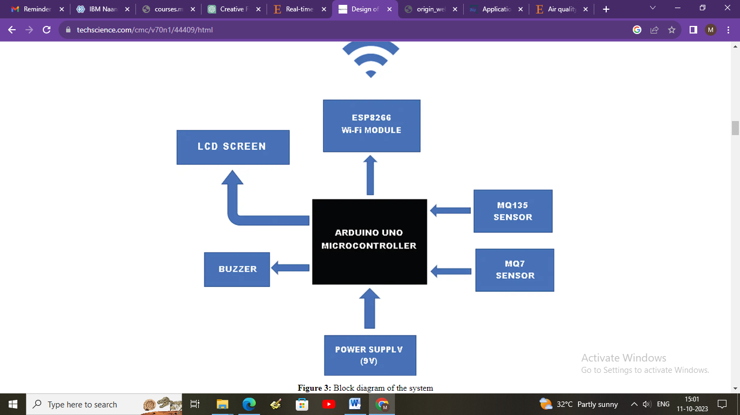

**PROGRAM:**

**// Define the analog pins for the MQ135 and MQ7 sensors**

**int mq135_analog_pin = A0;**

**int mq7_analog_pin = A1;**

**void setup() {**

**Serial.begin(9600);**

**}**

**void loop() {**

**// Read the analog values from the MQ135 and MQ7 sensors**

**int mq135_sensor_value = analogRead(mq135_analog_pin);**

**int mq7_sensor_value = analogRead(mq7_analog_pin);**

**// Convert the analog values to voltages**

**float mq135_voltage = (mq135_sensor_value / 1024.0) * 5.0;**

**float mq7_voltage = (mq7_sensor_value / 1024.0) * 5.0;**

**// Calculate the resistance of the sensors using a voltage divider formula**

**float mq135_resistance = ((5.0 - mq135_voltage) / mq135_voltage) * 10.0;**

**float mq7_resistance = ((5.0 - mq7_voltage) / mq7_voltage) * 10.0;**

**// Use the resistance values to estimate air quality for MQ135 and MQ7**

**int air_quality_mq135 = getAirQuality(mq135_resistance);**

**int air_quality_mq7 = getAirQuality(mq7_resistance);**

**// Print the results**

**Serial.print("MQ135 Air Quality: ");**

**Serial.print(air_quality_mq135);**

**Serial.println(" ppm");**

**Serial.print("MQ7 Air Quality: ");**

**Serial.print(air_quality_mq7);**

**Serial.println(" ppm");**

**delay(2000); // Delay for 2 seconds between readings**

**}**

**// Function to estimate air quality based on sensor resistance**

**int getAirQuality(float sensor_resistance) {**

**// You will need to calibrate your sensor based on its datasheet**

**// These values are for reference and may need adjustments**

**if (sensor_resistance <= 25) {**

**return 10000; // Very poor air quality**

**} else if (sensor_resistance <= 50) {**

**return 8000; // Poor air quality**

**} else if (sensor_resistance <= 100) {**

**return 5000; // Moderate air quality**

**} else if (sensor_resistance <= 200) {**

**return 2000; // Good air quality**

**} else {**

**return 1000; // Excellent air quality**

**}**

**}**

**CONCLUSION:**

Air quality in the chemical industry is a vital aspect of operations that has far-reaching implications for human health, environmental sustainability, regulatory compliance, and public safety. Chemical processes often release various pollutants and potentially toxic gases, necessitating comprehensive air quality monitoring and management systems**.**